**Curriculum Vitae**

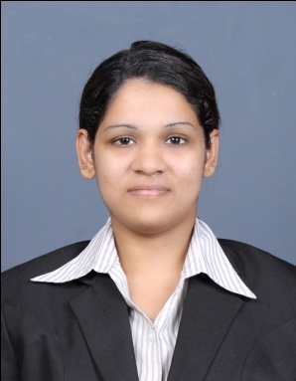

**Name:** Mervinia D’cruz

**Mobile number:** 8806525545

**E-Mail:**[merviniadcruz@yahoo.in](mailto:merviniadcruz@yahoo.in)

**Objective:**

I want to work towards becoming the head of Human Resource department in a large corporate in 10 years.

**Educational Qualification:**

* MBA-HR from Karnataka University
* B.COM from Goa University
* 12thStandard from Goa Board

**Professional experience:**

March 18th to May 22nd 2014: Internship at Nestle India Limited: worked in Corporate affairs department and Human Resource department.

**Projects Undertaken:**

* **“** Analyzing the effective Usage of Contractual working hours and creating shared value at Nestle India Limited”
* Project done on “assessment of customer satisfaction-a study of Dominos outlet in Porvorim” in December 2013.
* “ Comparitive study to determine the attributes of purchase decisions made by consumers of Cadbury and Nestle chocolate brands”

**My strengths:**

* I am strong in communication skills
* I love working in a team
* Willingness to learn
* I am hardworking, confident, honest, sincere and responsible in my work.

**Honours and achievements:**

* completed grade 1,2 and grade 4th in theory of music, grade 2 and 3 in violin and grade 2 in electronic keyboard from Trinity college London.
* First place in Quiz competition

**Articles written:**

* Written article on “Human resource management event”-college newsletter-2014
* Written article for “ Baking an Entrepreneur”- college newsletter-2014
* Written article on “Industrial visit”- college newsletter-2014
* Article on “St Francis Xavier’s Café, Mapusa”- For Panjim Plus Newspaper -2008

**Extracurricular Activities:**

* Editor of Srujan- SSIMS college newsletter
* Member of Goa Management Association
* Participated in organizing team of Crisis management event for Disha held in September 2013.
* Participated in organizing team of Bhruti held in November 2013.
* Participated in organizing team of Human Resource Management in September 2014.
* Played Electronic keyboard and violin in Kala Academy

**Seminars attended:**

* Attended AIMA shaping young minds program held in October 2013
* Attended a talk on “Law Of Attraction” By Harish Mehta
* Attended NIPM seminar of “In persuit of excellence” By Nikhil Dessai in November 2014

**Personal Data:**

|  |  |
| --- | --- |
| **Name** | Mervinia D’cruz |
| **Date of birth** | 17th April 1993 |
| **Sex** | Female |
| **Marital status** | Unmarried |
| **Nationality** | Indian |
| **Languages known**  **Address**  **Reference :**  **Contact number Designation :** | English, Konkani and Hindi  Cruz Vaddo, Marna Siolim Bardez Goa.  Mario Fernandes  7875553414  Assistant Manager Of Corporate Affairs at Nestle India Limited |

----------------------------------------------------------------------------------------------------